- Shramdaan Activity taken up from 11.09.2019 to 15.09.2019 to clean Offices, Almirahs, Storage, Cabinets and Tables etc.

- Through Cleaning of establishment section of IRICEN was done
Before After

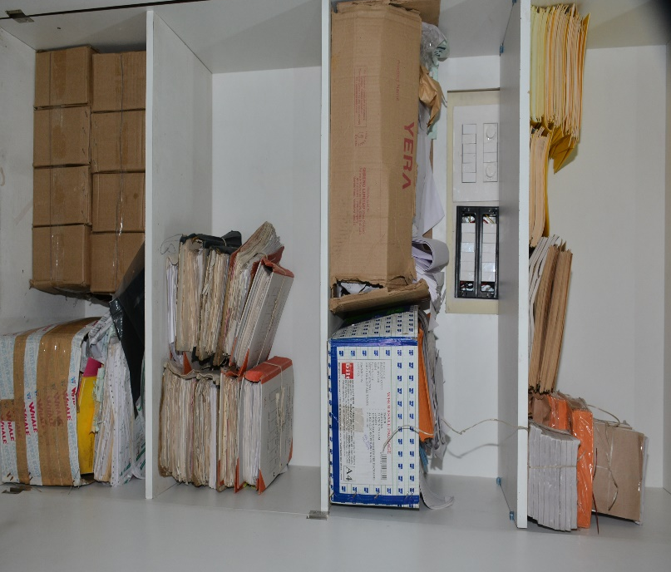

(B) Thorough cleaning of computer section of IRICEN was done
Before After
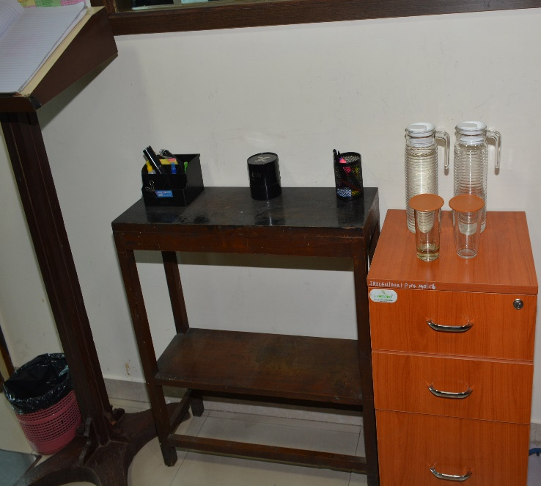
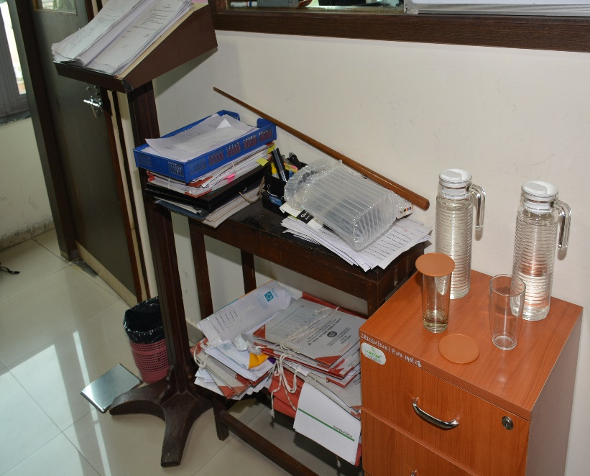

Before After
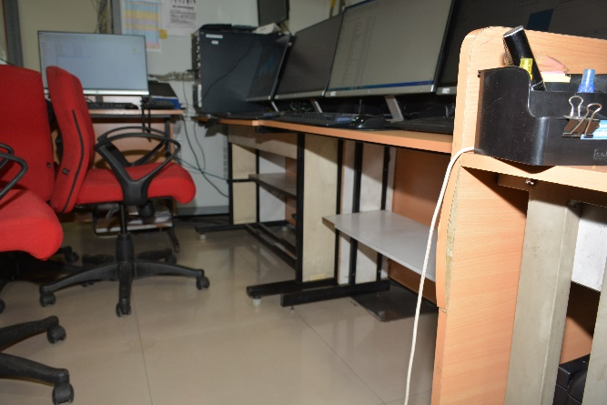
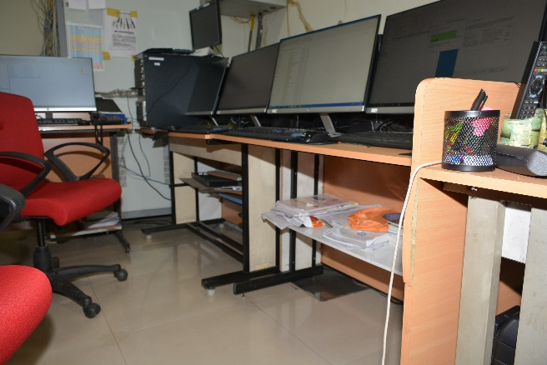

(C) Thorough cleaning of Laboratory of IRICEN was done

Before After
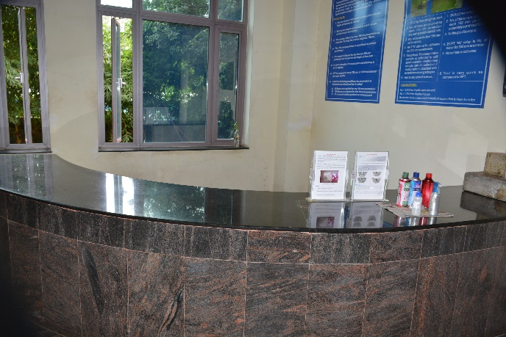
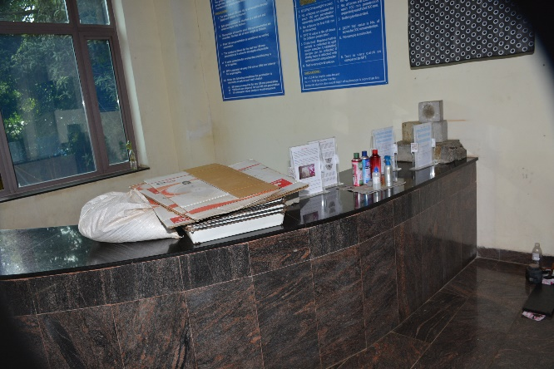

(D) Thorough cleaning of office of Sr. Instructor/Track -3 was done

Before After
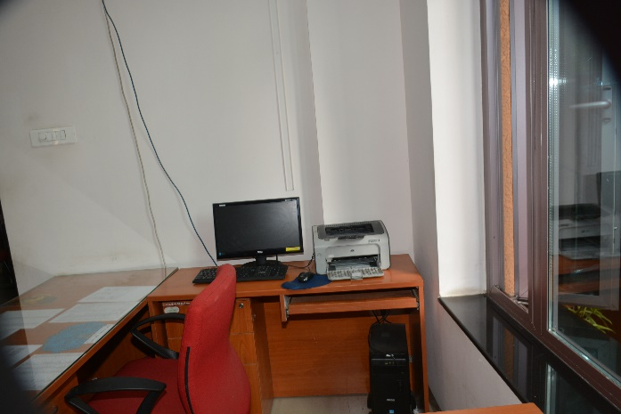
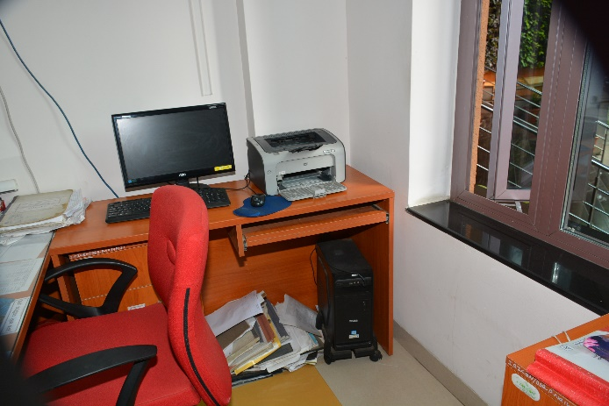

(E) Thorough cleaning of Pay Section of IRICEN was done

Before After
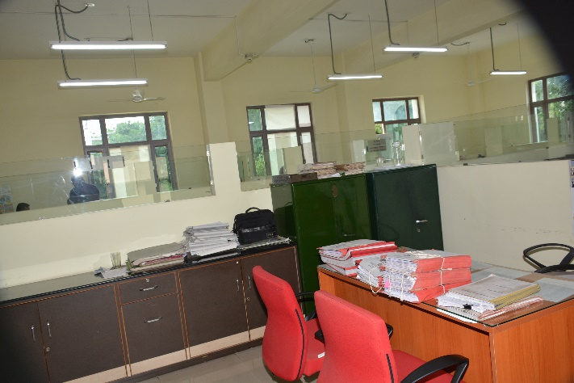
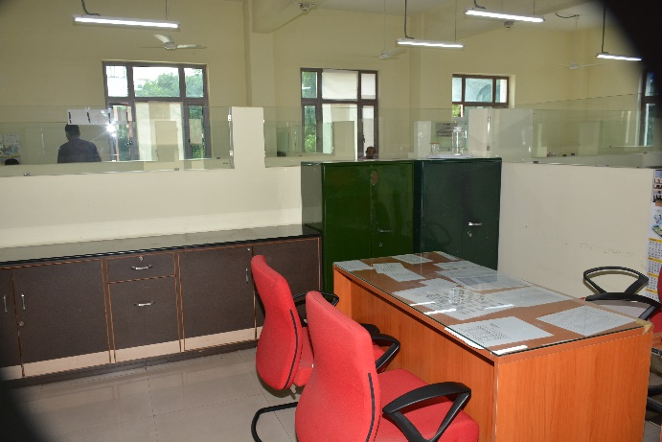

2. 16.09.2019 Swachh Awareness

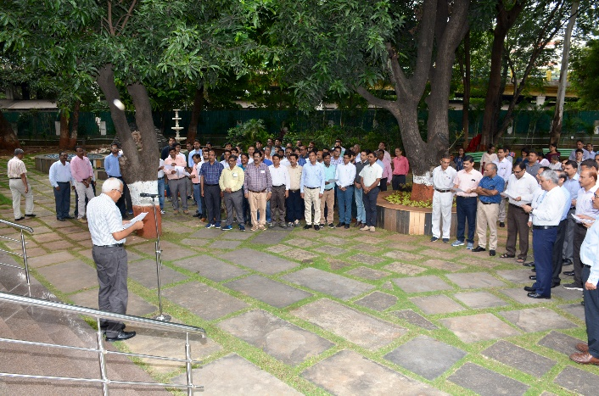
- Administrating Pledge at IRICEN by Director, IRICEN ( to all Railway staff, their families and all Safai Karmchari)
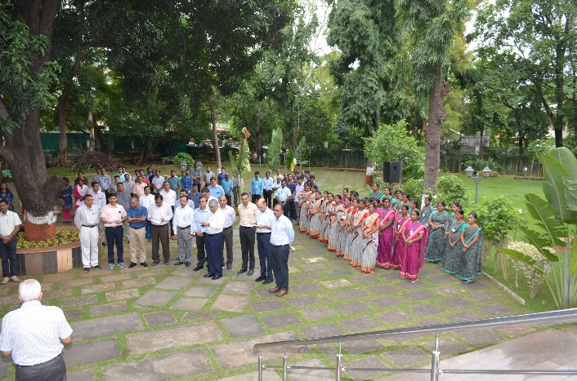

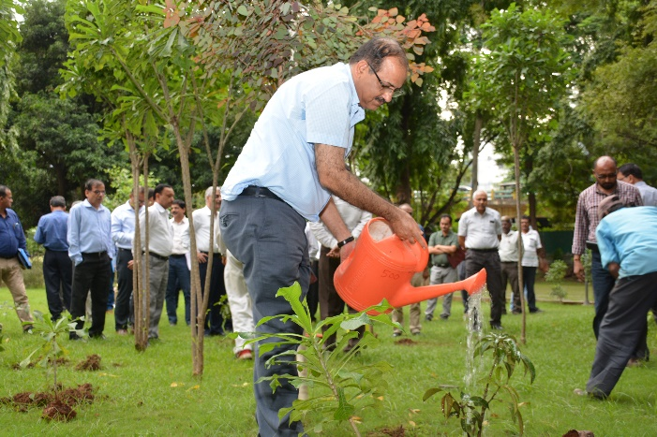
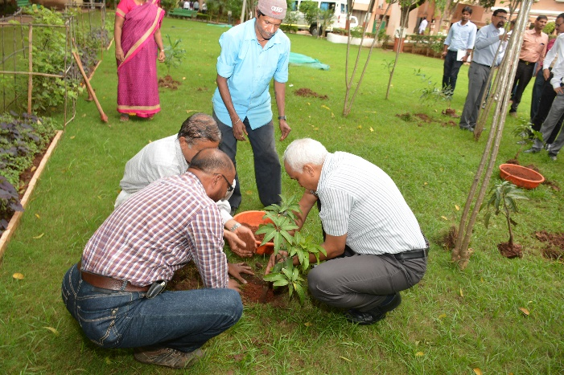
- Tree Plantation in IRICEN, Pune

3. 17.09.2019 Swachh Samwad

Seminar conducted on sanitation and upkeep of Railway colonies and Institute.
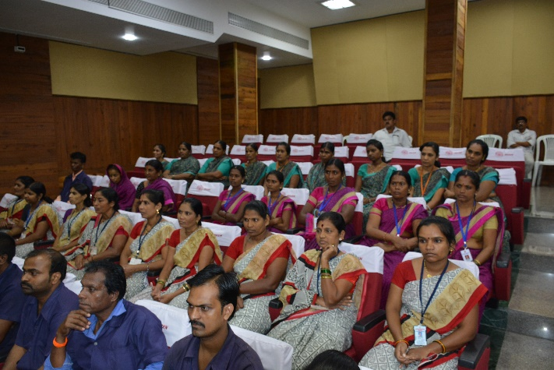
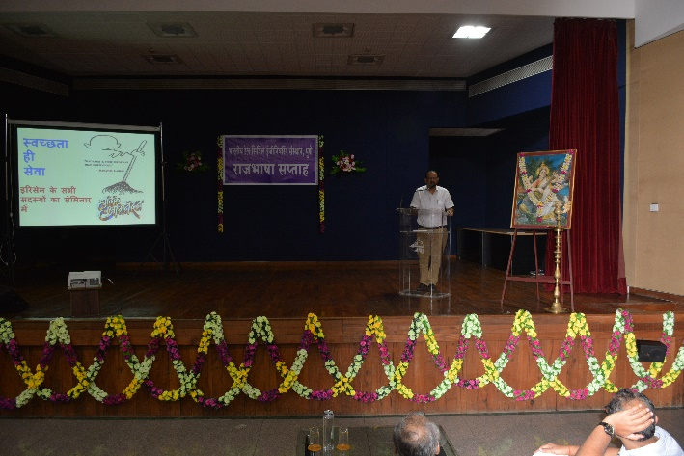
4. 18.09.2019 Swachh Samwad

Cleanliness notices displayed at various locations in IRICEN.

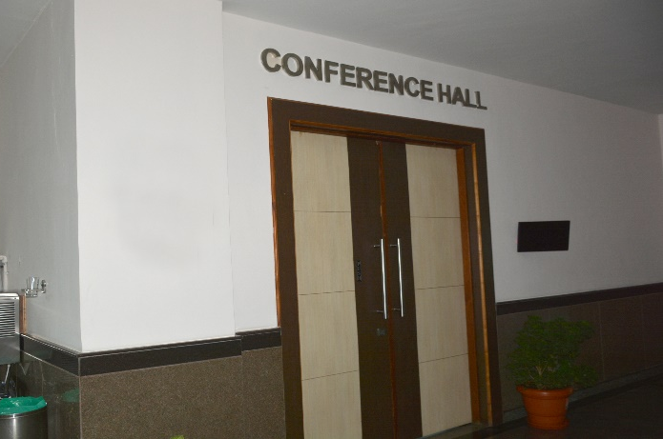
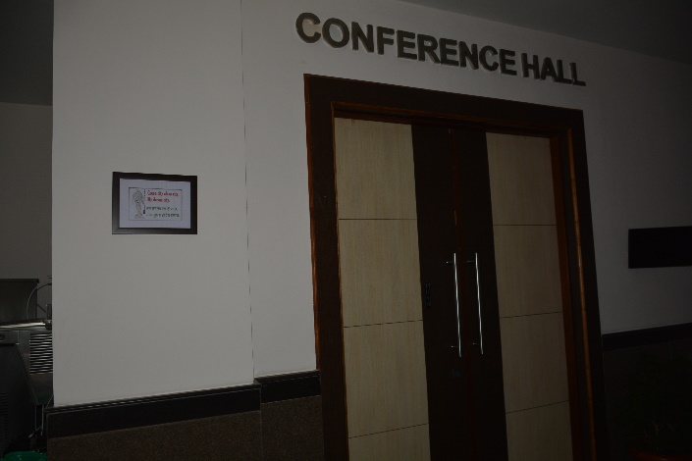
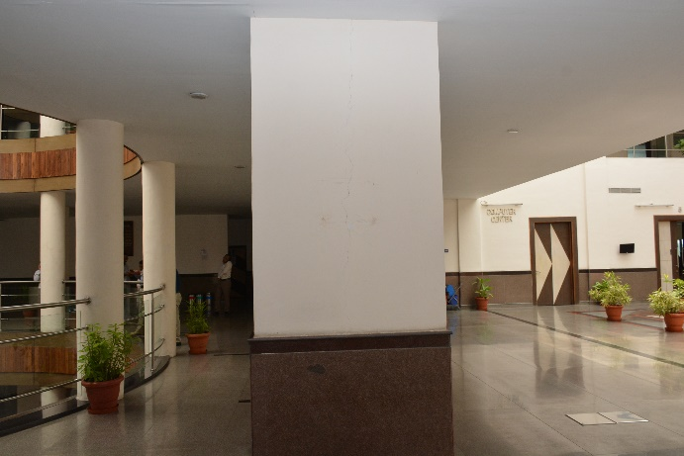
Before After
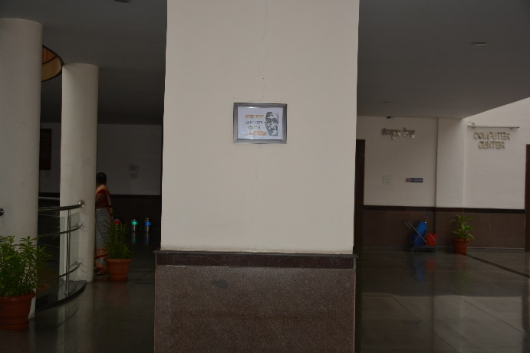

5. 22.09.2019 Swachh Parisar

Intensive Cleaning to clean and improve cleanliness in Railway colonies and rest houses.

Before After

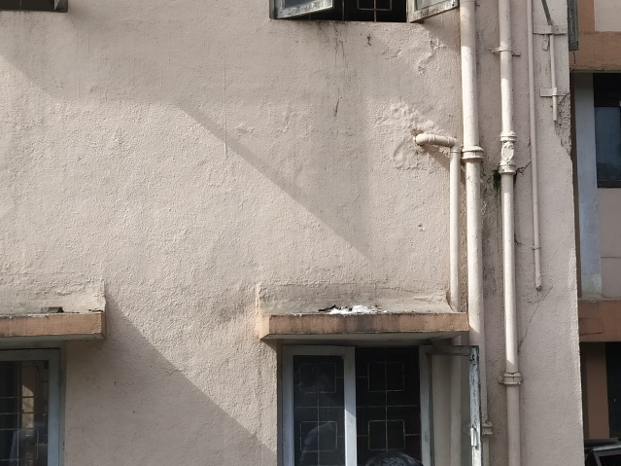
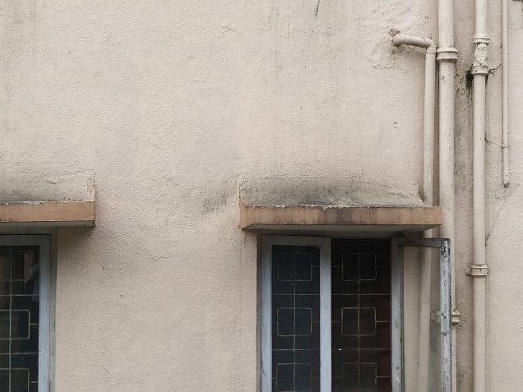

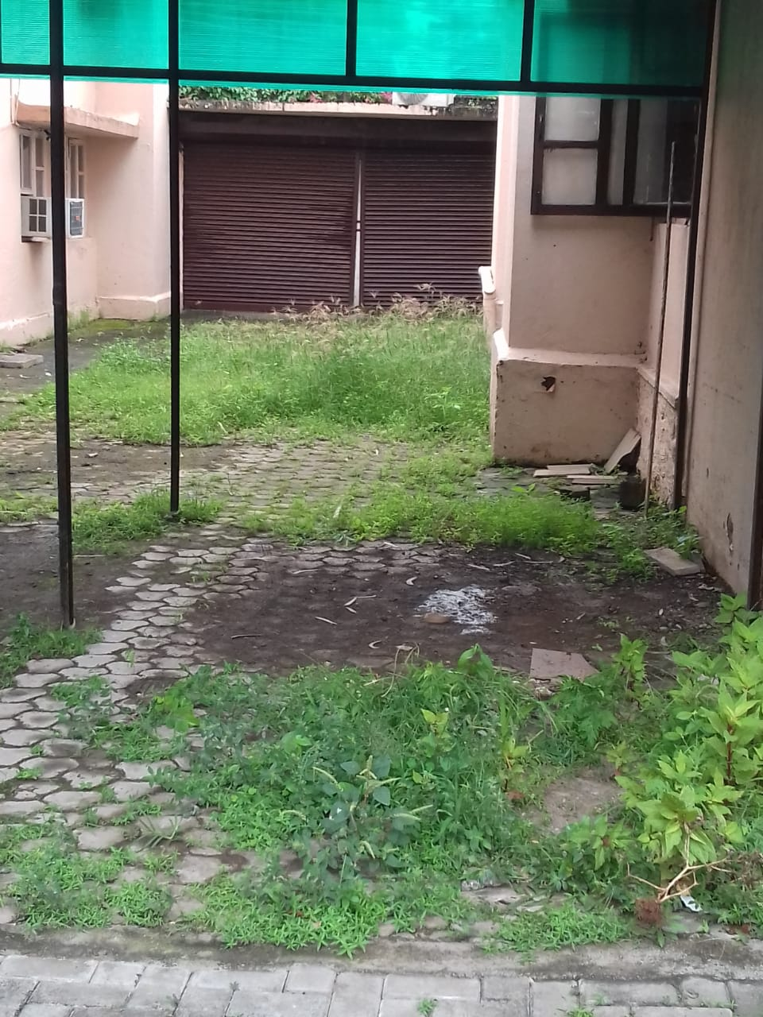
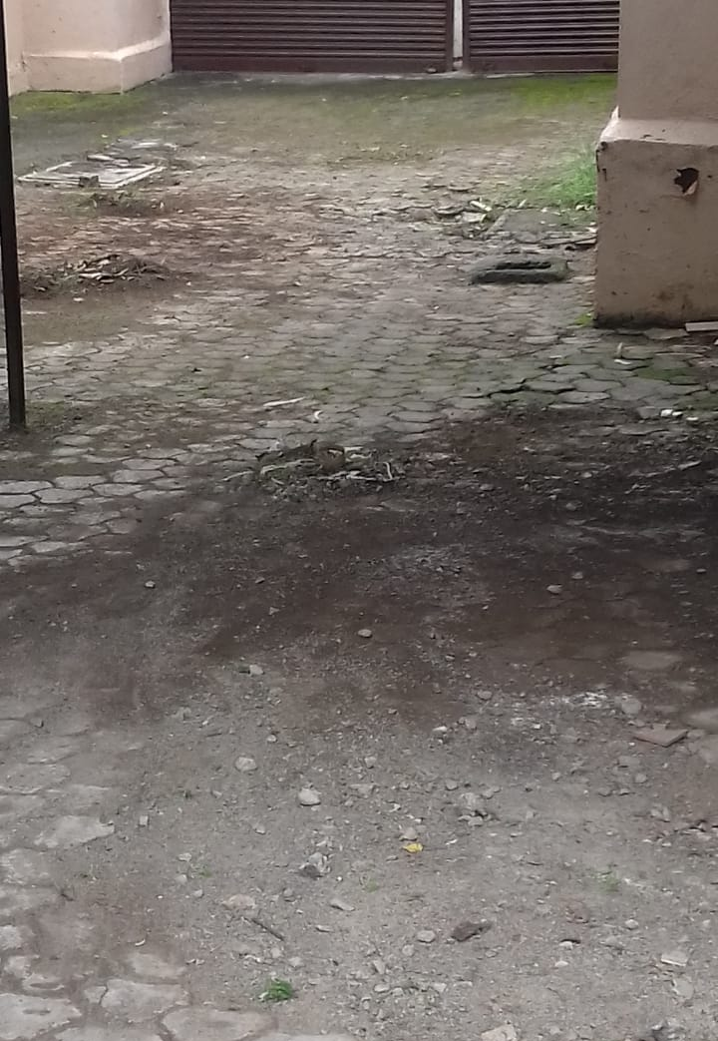

6. 23.09.2019 Swachh Parisar

Intensive Cleaning to Railway colonies and Residential Premises.

Before After
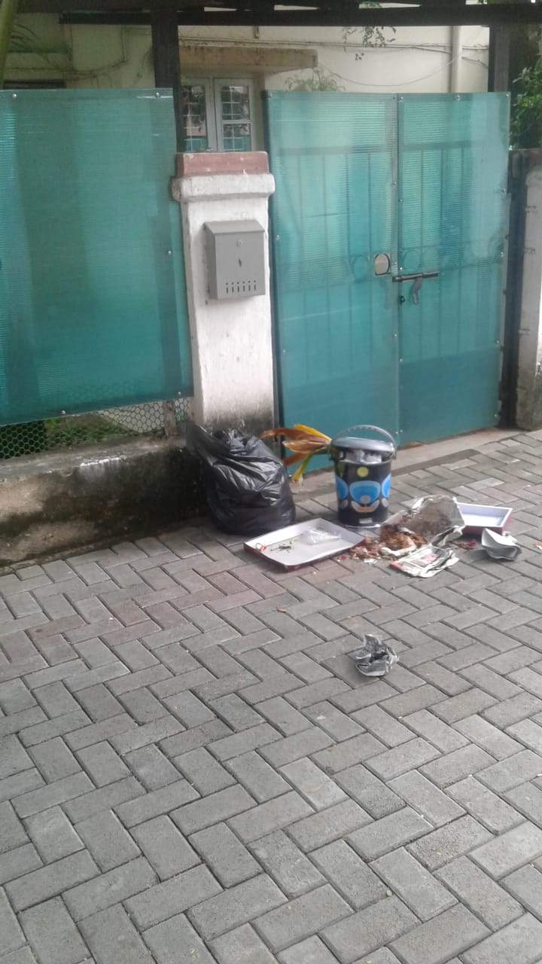
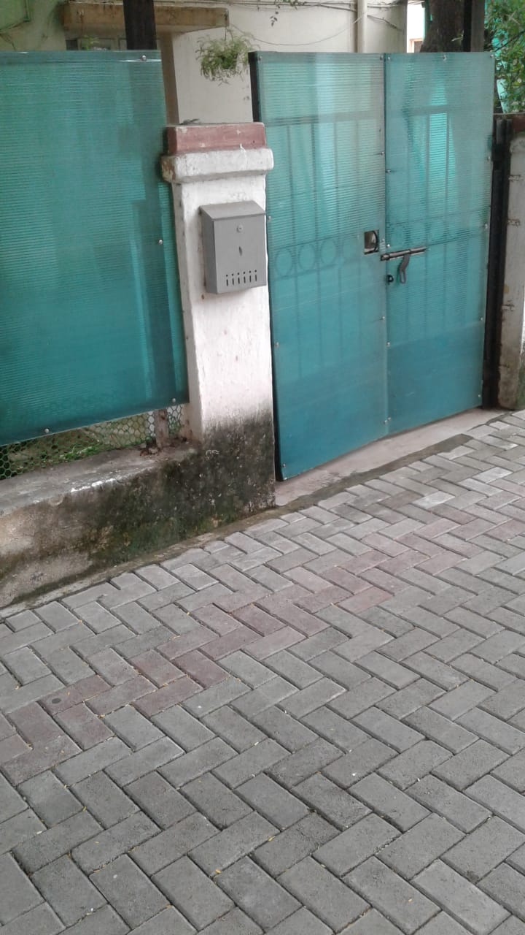

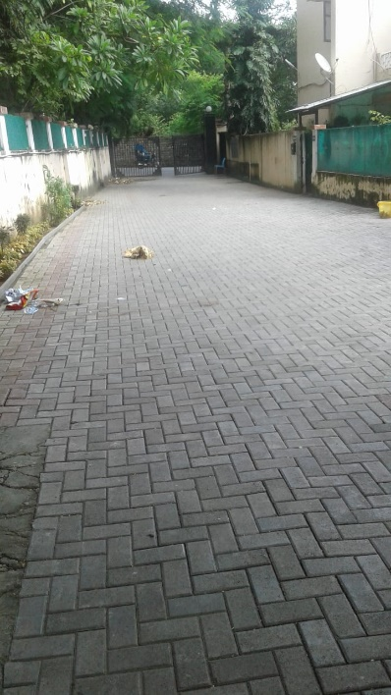
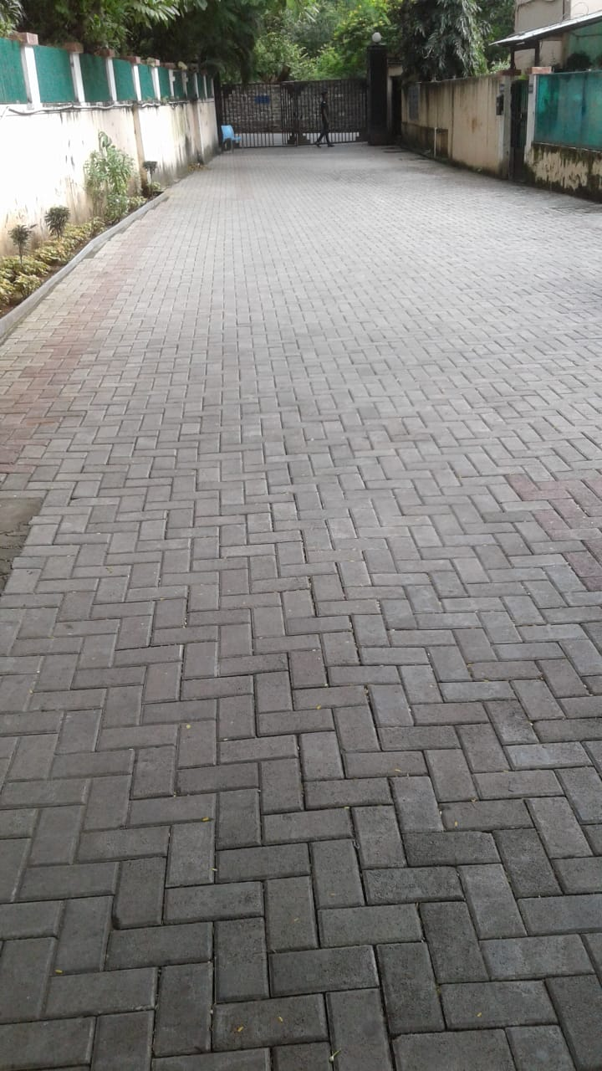

7. 26.09.2019 Swachh Neer

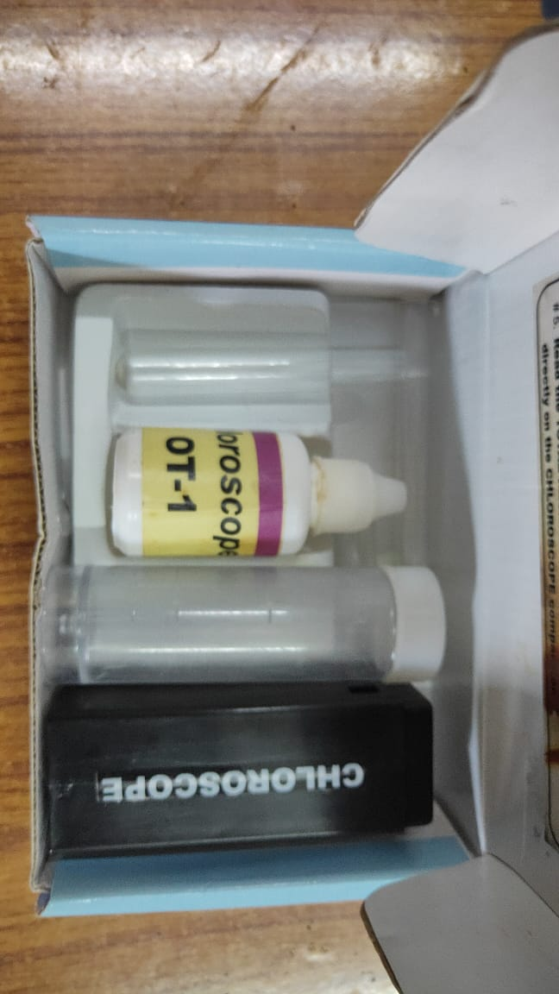
Water testing of hostel kitchen.

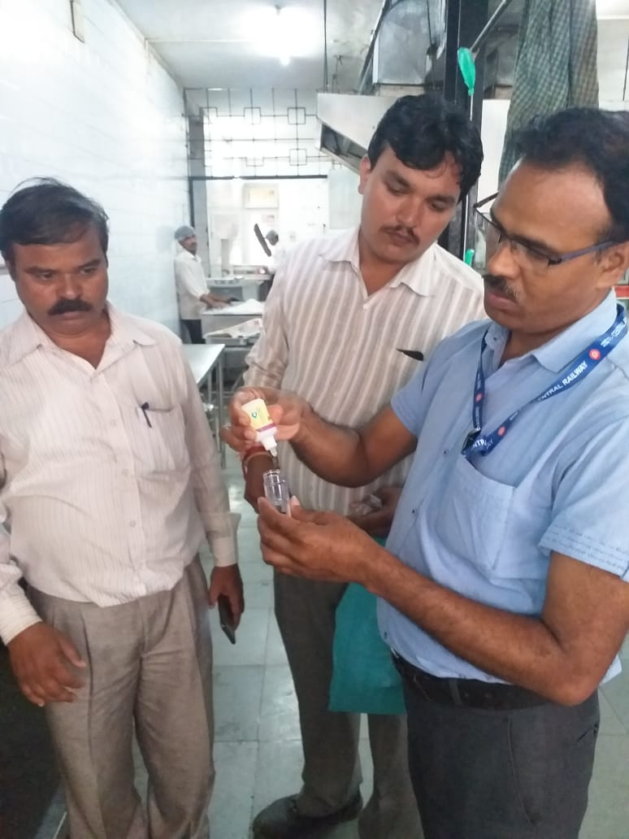

8. 27.09.2019 Swachh Neer

Intensive Cleanliness of Water Storage Tank.

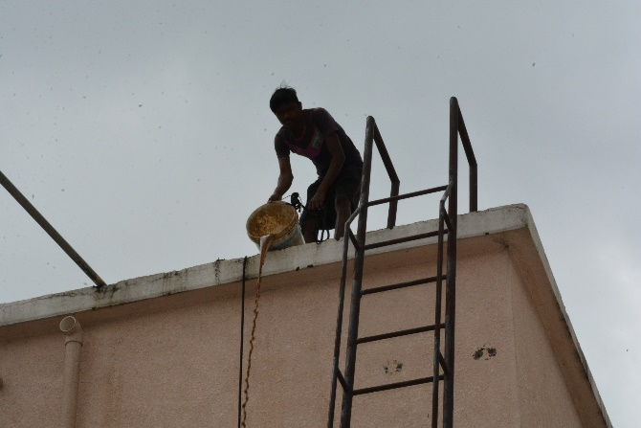
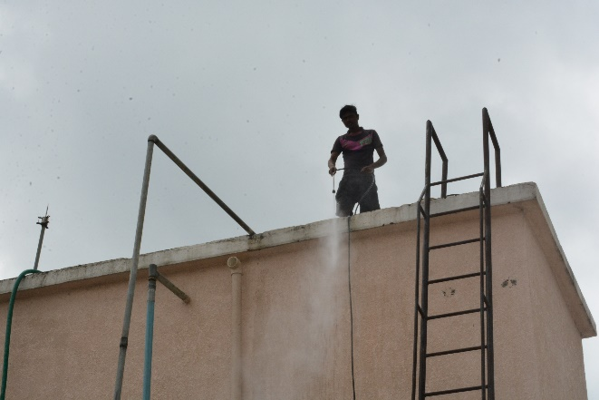

8. 28.09.2019 Swachh Prasadhan

Intensive Cleaning of Toilet blocks at office premises.

